Accessibility Guide for CALMARE
Date: 12/05/14
THIS DOCUMENT IS AVAILABLE IN OTHER FORMATS ON REQUEST

Introduction
CALMARE is part of the Harrison building and is accessed via the CALM/CALMARE and X-AT reception at the rear of the building NOT the main reception.

Location
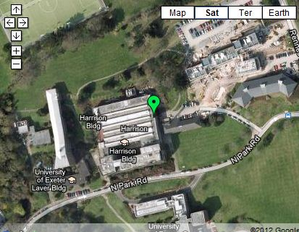
The venue is situated within the centre of the campus.
This venue is situated in Streatham Campus.
The venue is on a road with a steep gradient.
The nearest mainline Railway Station is St David’s.
There is a bus stop within 150m (164yds) of the venue.

Parking
This venue does have its own car park (at the rear of Harrison)
Parking is free for Blue Badge holders.
The car park is at the front of the venue (CALMARE reception).
The car park type is open air/surface.
There are 2 designated disabled parking bays within the car park.
The route from the car park to the entrance is accessible to a wheelchair.
The car park surface is tarmac.
The patron does not have to cross a road.
The car park does not have a height restriction barrier.
There is not a designated drop off point.

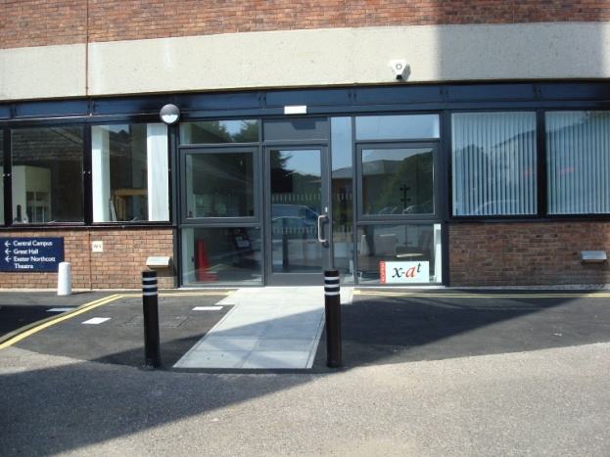
Outside Access (Main Entrance)

This information is for the entrance located at the side of the building.
There is level access to the service.
The main door opens away from you (push).
The door is single width.
The door is heavy.

Reception
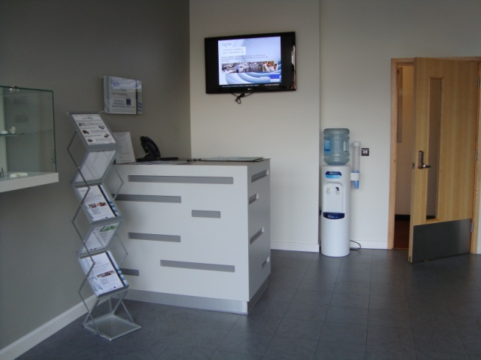
The reception desk is 4m (13ft 1in) from the main entrance.
There is level access to reception from the entrance.
The reception desk is medium height.
The desk does not have a lowered section.
Lighting levels are medium.

Inside Access
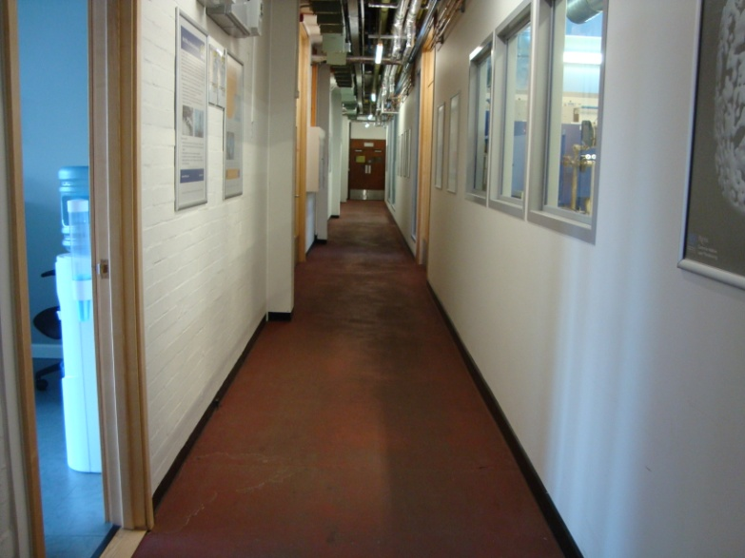
There is level access to the service.
There is a hearing assistance system.
The system is a portable loop, which was last tested in May 2014.
This venue does not play background music.
The lighting levels are varied.
Motorised scooters are allowed in public parts of the venue.

Meeting rooms

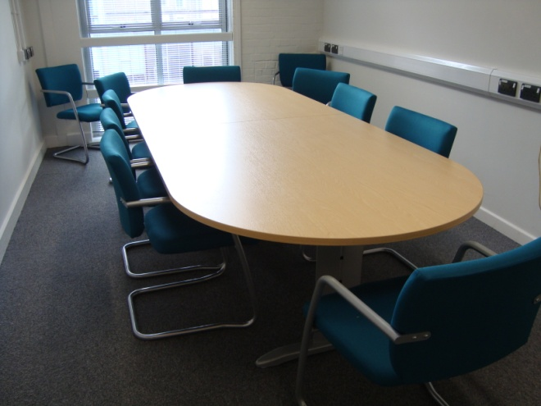
CALMARE uses two meeting rooms.
One is in the reception area
One is on the first floor (accessible by the lift)

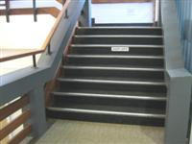
Other Floors

The floors which are accessible by stairs are G-1-2-3.
There are 15+ steps between floors.
The lighting level is medium.
The steps are clearly marked.
The steps are medium height.
The steps do have handrails.
The steps have a handrail on both sides.
There is a landing.
The services on the floors that are not accessible are Exeter Technologies Group offices.

Lift
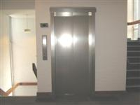

There is a lift for public use.
The lift is located to the rear of the corridor.
The lift is a standard. The floors which are accessible by this lift are G-1-2-3.
The lift is 100m (109yd) from the main entrance.
The dimensions of the lift are 1.09m x 1.3m (3ft 6in x 4ft 3in).
The clear door width is 86cm.
There are not separate entry and exit doors in the lift.
There is a mirror to aid reversing out of the lift.
The lift does have a visual floor indicator.
The lift does have an audible announcer.
The controls for the lift are within reach for a wheelchair user.
The lighting level in the lift is medium.
The lift does not have Braille markings.
The lift does have tactile markings.

Accessible Toilet
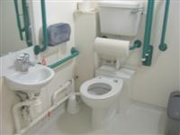
There are accessible toilets within this venue designated for public use.

Standard Toilet
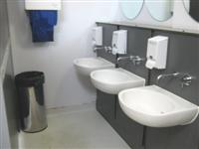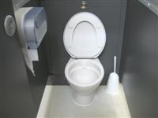

Availability and Location of Standard Toilets
Standard toilets are available.

Access to Standard Toilets
The female toilets are located by the lift (through double doors)
Inside the venue, there is level access to the female toilet.
The male toilets are located by the lift
Inside the venue, there is level access to the male toilet.
Lighting levels are medium.

Additional Information
Staff do receive disability awareness / equality training.
Documents can be requested in Braille.
Documents can be requested in large print.
A member of staff trained in BSL skills is not generally on duty.
This service can be requested.
Staff are not Text Relay aware.

