Name:
Company/Dept:
Course of study/Project:
Supervisor/Line manager:
Date:
Sample details:
Rough details required:
- No. Samples
- Rock type
- Rough size of each
- Rough weight of each
- Minerals present
- Location collected

Please mark up the samples for thin section work.
Asbestos Risk? | Does it contain amphibole/serpentine minerals/rocks? (e.g. Tremolite, amosite, crocidolite, chrysotile etc.). If so, please indicate below.
Radioactive Risk? | Does it contain U, Th, REE minerals/rocks? If so, please indicate below.

Table guidance: Please only tick if the answer is yes. If the samples are all similar please use one column as ‘batch’, new column per batch that has different hazards. Any answers ticked require further details in the section under the table.

Sample(s) name:
Symbol | Potential Hazard
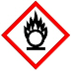 | Oxidising | ☐ | ☐ | ☐ | ☐
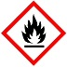 | Flammable | ☐ | ☐ | ☐ | ☐
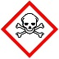 | Toxic | ☐ | ☐ | ☐ | ☐
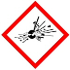 | Explosive | ☐ | ☐ | ☐ | ☐
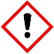 | Irritant | ☐ | ☐ | ☐ | ☐
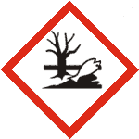 | Dangerous to the environment | ☐ | ☐ | ☐ | ☐
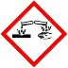 | Corrosive | ☐ | ☐ | ☐ | ☐
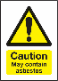 | Asbestos Risk | ☐ | ☐ | ☐ | ☐
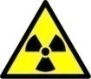 | Radioactive | ☐ | ☐ | ☐ | ☐
? | Other (fill in the next section) | ☐ | ☐ | ☐ | ☐
 | Non-hazardous | ☐ | ☐ | ☐ | ☐
Please provide additional details below (mandatory):

Sample disposal
Sample disposal remains the responsibility of the person submitting the sample(s), except by prior written agreement from the Lab Staff.
Declaration
I declare that the information provided above is accurate and I understand the requirements for Health & Safety and the implications of providing a false statement. I agree that sample storage and disposal is my responsibility. I confirm that my supervisor has been informed.
Name:
Date:
Signed (if electronic, filling out your name is sufficient):

